**Files in Docker Container:**

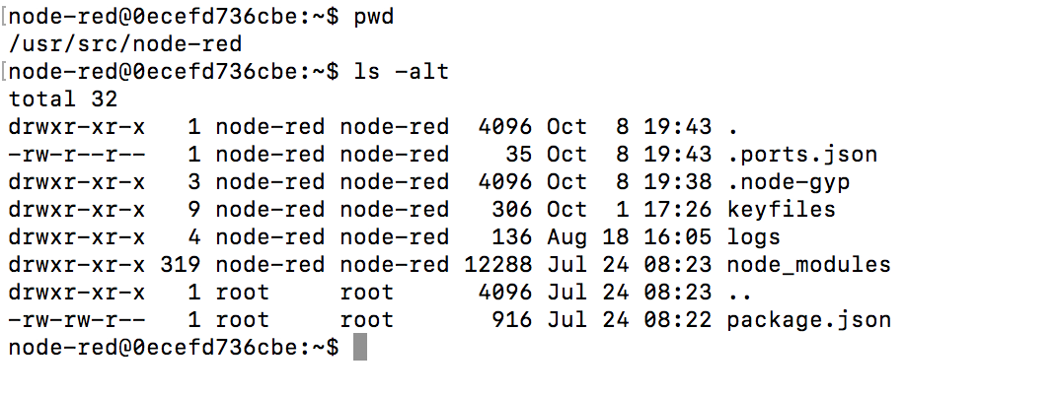

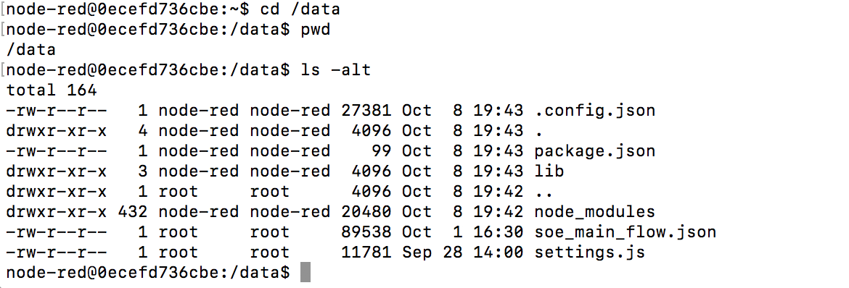

Conents of Package.json in Container

**Container Folder: /data**

{

    "name": "node-red-project",

    "description": "A Node-RED Project",

    "version": "0.0.1"

}node-red@1937e7b7804f:/data$

**Container Folder: /usr/src/node-red**

{

    "name": "node-red-docker",

    "version": "1.0.0",

    "description": "A visual tool for wiring the Internet of Things",

    "homepage": "http://nodered.org",

    "license": "Apache 2.0",

    "repository": {

        "type": "git",

        "url": "https://github.com/node-red/node-red-docker.git"

    },

    "main": "node_modules/node-red/red/red.js",

    "scripts": {

        "start": "node $NODE_OPTIONS node_modules/node-red/red.js -v $FLOWS"

    },

    "contributors": [

        {

            "name": "Dave Conway-Jones"

        },

        {

            "name": "Nick O'Leary"

        },

        {

            "name": "James Thomas"

        }

    ],

    "dependencies": {

        "node-red": "0.17.5",

        "node-red-node-msgpack": "*",

        "node-red-node-base64": "*",

        "node-red-node-suncalc": "*",

        "node-red-node-random": "*"

    },

    "engines": {

        "node": "4.*.*"

    }

}